# **Levelling Up Travel Audio: iFi launches UP Travel Bluetooth DAC**

**New travel-ready Bluetooth DAC for life on the move**



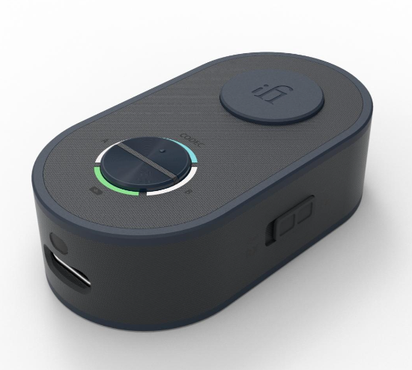

**Southport, UK** – iFi audio - a trailblazer in audio innovation and high-performance sound components - is proud to announce the **UP Travel,** the ultimate travel companion. Whether it’s by plane, train, or automobile, the UP Travel is the simplest and most effective Bluetooth audio essential you could ask for.

Designed to replace a clutter of adapters and cables, the UP Travel is a transmitter and receiver bringing **Hi-Res Bluetooth connectivity** everywhere you need it - from cars to in-flight entertainment systems and beyond. Travel-minded from the ground up, its sleek, ultra-light form factor slips effortlessly into a pocket, travel bag, or carry-on at a feather-light 25g – with a 10-hour battery life to keep the music going from take-off to touchdown.

With dual headphone support, two listeners can share the wealth of the UP Travel’s innovative design and tune in together for films, playlists, or podcasts – without the hassle of syncing screens or settling for second-best sound.

The engine driving this innovation is iFi’s renowned Hi-Fi-grade architecture, which rejects System-on-Chip compromises in favour of finely tuned, independent audio stages, extracting maximum performance while maintaining a truly pocketable form factor.

**Key Features of the UP Travel include:**

* Connects Bluetooth headphones to in-flight entertainment
* Streams Hi-Res Bluetooth to car AUX inputs
* Hi-Fi Circuitry with a Cirrus Logic DAC
* Dual Bluetooth headphone pairing
* Built-in mic with cVc noise & echo suppression
* Up to 10 hours of battery life

### **Travel by Name. Travel by Design.**

The UP Travel is everything a modern traveller needs: it’s easy to use, compatible with a wide range of devices, and so incredibly lightweight that it easily meets even the strictest baggage limits.

Inspired by the sleek mechanics of a switchblade-style car key, the UP Travel powers on and deploys its built-in 3.5mm connector at the press of a button – flipping out in one smooth, satisfying motion. From there, it’s as easy as pairing with your Bluetooth device – just one more press and you’re connected.

When your journey ends, the connector folds back into place and powers off automatically, ready to slip effortlessly into your pocket until next time.

### **One Switch. Endless Possibilities.**

Beneath the simplicity of the UP Travel’s clean, minimalist design lies its true genius. With the flick of a switch, the UP Travel can alternate between transmitter (TX) and receiver (RX) modes, opening the door to two transformative Bluetooth experiences.

Switch to TX mode and you can give your in-flight entertainment a first-class ticket to the modern age of audio, with a full suite of Hi-Res codecs. Users can cast aside the tangle of cables and adapters and get even greater value from their wireless headphones and earbuds.

If productivity is your priority, the UP Travel has you covered there too. Plug it into your laptop’s 3.5mm output and add premium Bluetooth audio to your journey. Perfect for video calls or catching up on your favourite podcasts while you ride. The UP Travel brings the class, so you can take care of business.

Behind the wheel? The UP Travel brings serious upgrades to your car’s audio, too. Switch the UP Travel to RX mode, connect it to your car’s AUX input, and your car’s stereo system is transformed with Hi-Res Bluetooth streaming capabilities – a feature even high-end car systems often lack. Your car’s sound system will sing out like never before, with greater clarity and detail than you’ve ever heard while in the driver’s seat.

### 

### **Pure Hi-Fi at Its Core.**

The UP Travel is the only device in its class that uses true Hi-Fi grade architecture.

At its core lies a carefully curated lineup of audiophile-grade components, each optimised for a specific role to maximise overall audio performance.

First is the Qualcomm QCC51xx series Bluetooth chipset. Where other products would have this chipset handle every stage of the audio processing, iFi assigns it a singular, focused task: delivering a wide range of high-quality Bluetooth codecs with rock-solid transmission and reception.

Next is the Cirrus Logic MasterHIFI DAC, also found in several of iFi’s award-winning portables. Chosen for its exceptional fidelity and power efficiency, it delivers detailed, accurate sound with wide dynamic range and minimal distortion—while conserving battery life to extend playtime.

Completing the chain is iFi’s bespoke clocking circuitry, engineered to keep all components performing like clockwork with one another. Together, these specialised components sum to a refined, tailored experience, that raises the bar for what can be expected – and delivered – by a Bluetooth adapter.



### 

### 

### **Two’s Company.**

There’s something magical about putting on headphones and getting lost in your favourite music or movie. It’s an escape, a moment just for you. Yet sometimes, that solitude is exactly what you want to break – you want to share that experience with someone close.

The UP Travel makes it possible. Connect seamlessly to two pairs of headphones or earbuds, with no syncing struggles or compromise in sound – whether you’re on the ground or 30,000 feet in the air.

Simply connect, press play, and get lost in that moment together.

### **Smart Codecs. Smarter Sound.**

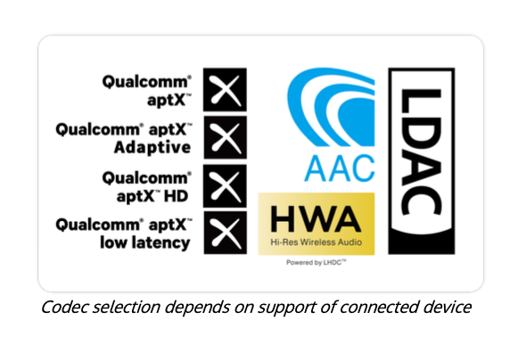

The UP Travel ensures maximum compatibility across your devices by incorporating a comprehensive suite of codecs – SBC, AAC, aptX (Classic, Low-Latency, Adaptive), LDAC, and LHDC/HWA. Phones, tablets, headphones – no matter what codecs your hardware uses, iFi guarantees an option for you.

This expansive range allows not just for compatibility, but flexibility – the UP Travel has codecs dedicated to both high fidelity (perfect for music and audiobooks), along with options for low latency, ensuring your audio is synced up perfectly for in-flight movies and video entertainment.

The UP Travel’s hardware design allows for quick switching between codec options, so you’re never more than a button press from what you need at any given moment. If you’re unsure of whether you’re using the correct codec for the job, a long press of the codec button announces the active profile.

### **Call Quality that Cuts Through.**

From music playback to hands-free calls, the UP Travel is built to handle it all.

A built-in microphone at the base, combined with Qualcomm’s cVc noise and echo suppression technology, ensures every call is crisp and clear. Whether it’s an urgent business call in transit, airports, or cafes, The UP Travel intelligently filters out background noise in real time to ensure your voice is heard.

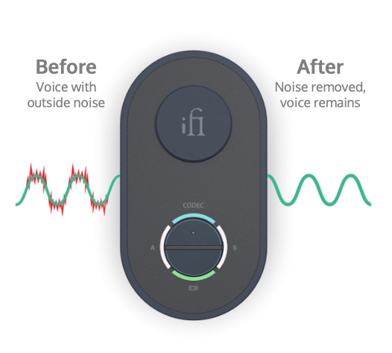

### 

### **Powered by iFi Nexis.**

The UP Travel is also compatible with the iFi Nexis app, available on both iOS and Android. Designed to act as a central hub for all things iFi, Nexis lets you unlock additional features, personalise your settings, and keep your UP Travel updated with the latest firmware – ensuring it always performs at its best.



### **Pricing & Availability**

The **iFi UP Travel** is available to purchase at ifi-audio.com for £99/$99/€99.

**Media Contact:**[shelby@hummingbirdmedia.com](mailto:shelby@hummingbirdmedia.com)



iFi is the sister-brand of Abbingdon Music Research (AMR) and is headquartered in Southport, UK. The two brands respectively design and manufacture portable, desktop and lifestyle audio products and high-end hi-fi components. Combined in-house hardware and software development teams and a ‘music first’ approach enable iFi and AMR to create advanced audio products that deliver new levels of design, functionality and performance at their respective

price points. Since iFi’s formation in 2012, its products have earned many awards around the world, helping it to become one of the fastest-growing brands in its field.

[www.ifi-audio.com](http://www.ifi-audio.com)

# **Appendix**

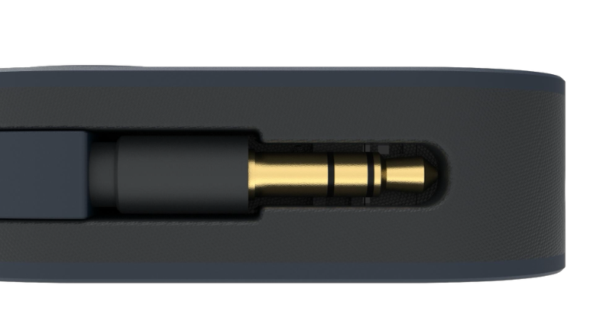

### **General Specification**

|  |  |
| --- | --- |
| **UP Travel** | |
| Bluetooth Codecs | LDAC, LHDC/HWA, aptX Adaptive, aptX Low Latency, aptX, AAC, SBC |
| Output Power (RMS) | 70mW/1.5V @ 32Ω |
| THD+N | ≤0.004% @ 1kHz, 32Ω |
| Dynamic Range | ≥120dBA @ 32Ω |
| Signal-to-Noise Ratio | ≥120dBA @ 32Ω |
| Battery | 400mAh |
| Battery Life | ≥10 Hours |
| Power System | 5V /≥500mA |
| Dimensions | 55 x 30 x 16.8mm (2.16 x 1.18 x 0.66”) |
| Net Weight | 25.7g (0.9oz) |

|  |  |
| --- | --- |
| **Connectivity** | |
| Inputs (TX) | Aux 3.5mm, USB-C |
| Inputs (RX) | Bluetooth 5.2 |
| Outputs (TX) | Bluetooth 5.2 |
| Outputs (RX) | Aux 3.5mm |

### **Codec LED Configuration**

|  |  |
| --- | --- |
| **TX Mode** | |
| **Format** | **LED Colour** |
| SBC | Off |
| AAC | Yellow |
| aptX | Blue |
| aptX HD | Magenta |
| aptX Adaptive | Green |
| aptX Low Latency | White |
| LDAC | Cyan |

|  |  |
| --- | --- |
| **RX Mode** | |
| **Format** | **LED Colour** |
| SBC | Off |
| AAC | Yellow |
| aptX | Blue |
| aptX HD | Magenta |
| aptX Adaptive | Green |
| LDAC | Cyan |
| LHDC(HWA) | Red |